Task Checklist

Video: [Task Checklist Video](https://drive.google.com/file/d/1uYy35-Qjw1UveAbrIaB-0BUJ_0PVWZ8b/view?usp=drive_link)

Table of Contents:

**Why is this feature important? 2**

How to access the Task Checklists? 3

Different sections of the Task Checklists 4

# 

# Task Checklist

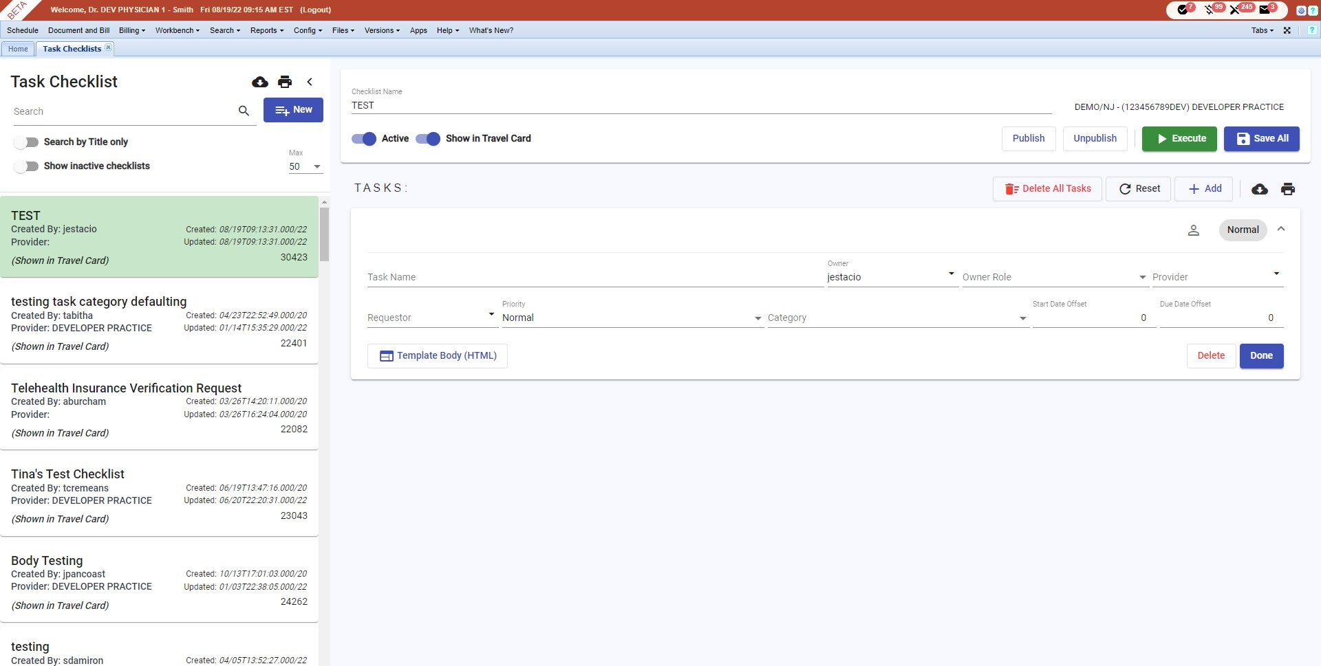A task checklist helps you open either a single task or a series of tasks, ensuring each one is tracked, logged, and managed individually for accountability and completion. It also removes the need to manually create tasks one at a time by creating a set of pre-configured tasks that are best suited for a specific workflow of the practice. Since it is preset by the practice, this removes the possible issue of tasks not being created manually, especially in high-volume practices. The Checklists Report shows the different task checklists in the system. This report helps you create a task and check the details of a task.

## 

## How to access the Task Checklists?

| Go to **Config →** hover over **System** → and click **Task Checklists.** |  |
| --- | --- |

## Different sections of the Task Checklists

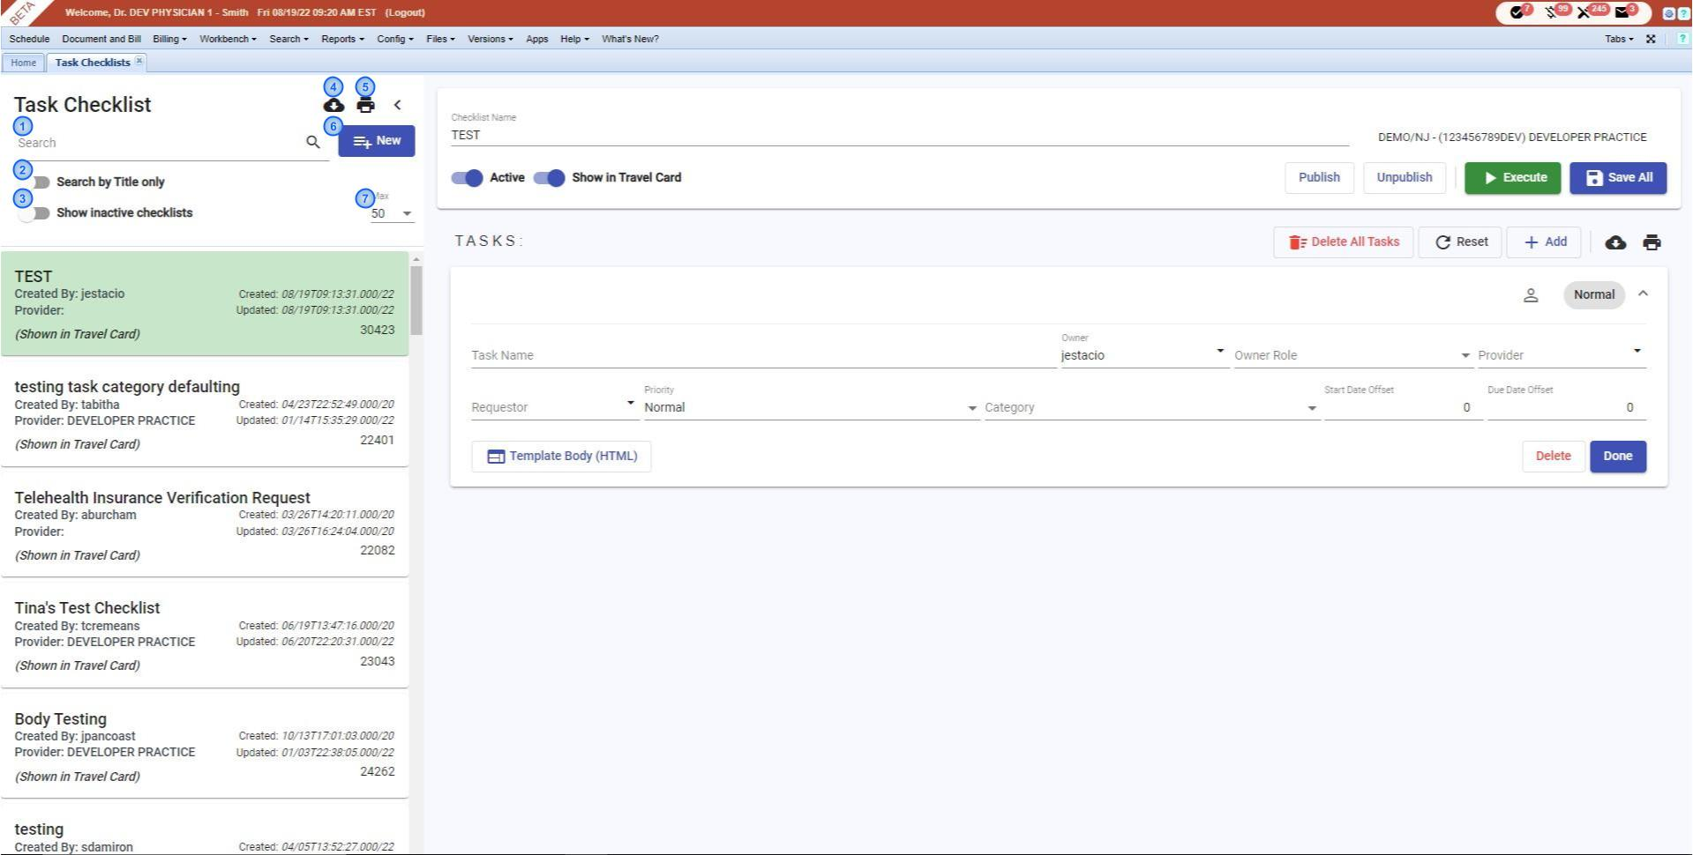**1. Search -** allows you to search for a specific checklist needed.

**2. Search by title only -** enabling this will allow you to search the checklists by their titles only.

**3. Show Inactive Checklists -** enabling this will allow you to search for inactive checklists only.

**4. Download -** allows you to download the results.

**5. Print -** allows you to print the forms as a .Csv file.

**6. New -** clicking this will create a new checklist.

**7. Max -** allows you to set a number of results you'd like to see in one page.

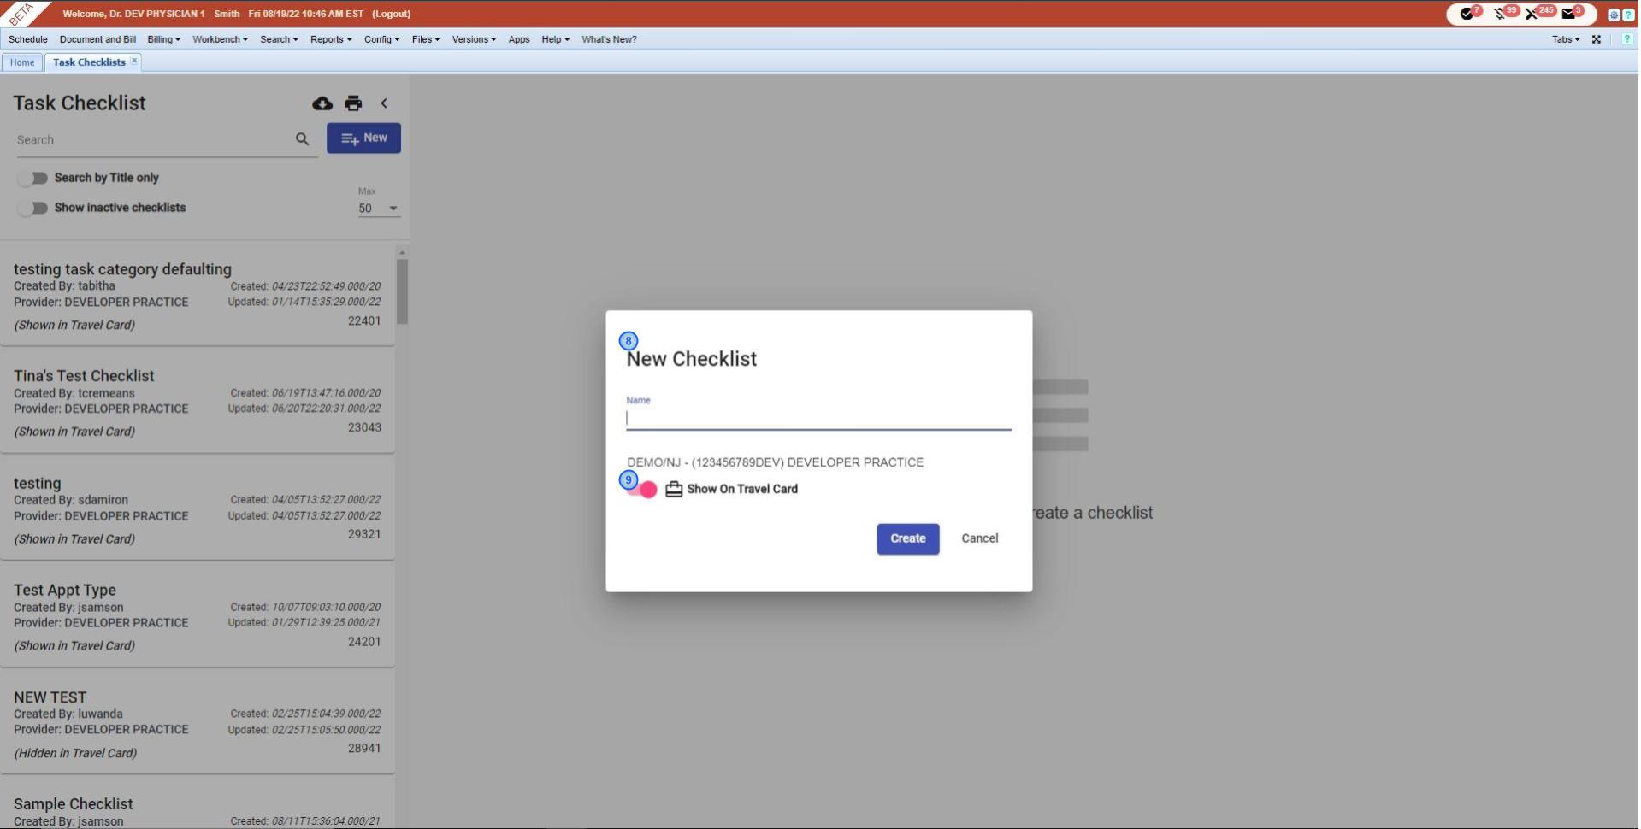**8. New Checklist -** here you can enter the name of your checklist, as well as enable or disable the show on travel card.

**9. Show On Travel Card -** clicking this will let you see or unsee the checklist on the travel card.

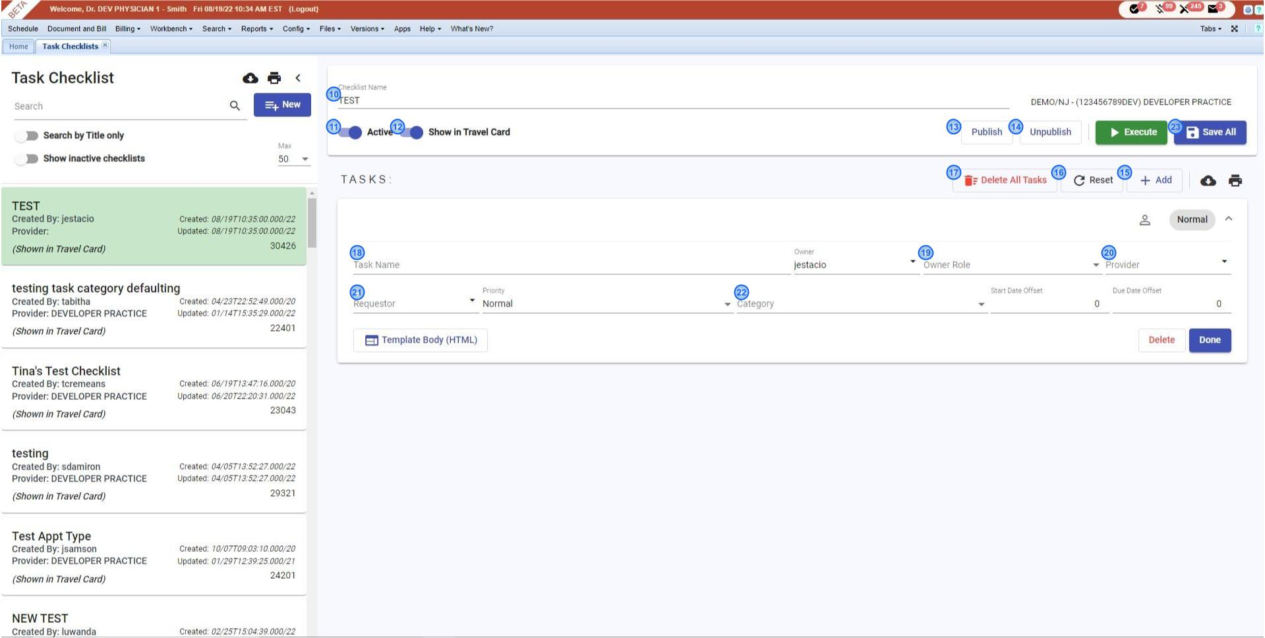**10. Checklist Name -** allows you to easily change the name of your checklist.

**11. Active -** you can disable this feature in case the checklist is no longer active.

**12. Show in Travel Card -** Disabling this feature will not show a checklist in the travel card.

**13. Publish -** allows you to publish your checklist. If the checklist is published, this checklist will be shown on the Task Checklist list and it can be accessed by other users in your practice.

**14. Unpublish -** allows you to unpublish your checklist. Click this button if you don’t want the other users in your practice to use or access this checklist

**15. Add -** allows you to add a new task in the checklist.

**16. Reset -** allows you to undo your changes and start again.

**17. Delete All Tasks -** allows you to delete the existing tasks from your checklist if you have any.

**18. Task name -** allows you to type in the task name.

**19. Owner Role -** allows you to select owner role.

**20. Provider -** allows you to select a provider.

**21. Requestor -** allows you to select a requestor.

**22. Category -** allows you to select a billing category.

**23. Save All -** clicking this, it will save all the changes in the system.